**Stream API**

* Stream API is used to process collections of objects.
* A stream is a sequence of objects that supports various methods which can be pipelined to produce the desired result.
* A stream is not a data structure instead it takes input from the Collections, Arrays or I/O channels.
* Streams don’t change the original data structure, they only provide the result as per the pipelined methods.
* Each intermediate operation is lazily executed and returns a stream as a result, hence various intermediate operations can be pipelined. Terminal operations mark the end of the stream and return the result.

**Intermediate Operations:**

1. **map:** The map method is used to map the items in the collection to other objects according to the Function passed as argument.  
   
2. **filter:** The filter method is used to select elements as per the Predicate passed as argument. 
3. **sorted:** The sorted method is used to sort the stream. 

**Terminal Operations:**

1. **collect:** The collect method is used to return the result of the intermediate operations performed on the stream. 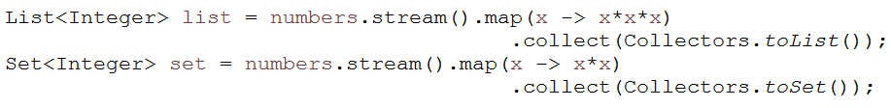
2. **forEach:** The forEach method is used to iterate through every element of the stream.



1. **reduce:** The reduce method is used to reduce the elements of a stream to a single value.